Vision Zero Prince George’s Project Map User Guide
Web Link: https://princegeorges.maps.arcgis.com/apps/webappviewer/index.html?id=0bc4fbf92d6748619d38adaac402952b
Description and Purpose
The Vision Zero Prince George’s Project Map shows completed or in progress projects that improve the safety of roadways within Prince George’s County. This includes projects implemented by the Department of Public Works and Transportation (DPW&T), the State Highway Administration, and other regional partners. The map includes localized projects, (represented as points) such as lighting, signage, and intersection improvements, and it includes larger projects, (represented as lines) such as bike lanes and capital improvement projects that cover a large area.
The map also includes two high injury networks. The Vision Zero High Injury Network shows the top 20 one-mile segments of roads throughout the County with the greatest severity of bike and pedestrian crashes. The County Roadway High Injury Network shows the top 20 one-mile segments of roads that are maintained by DPW&T with the greatest severity of bike and pedestrian crashes.
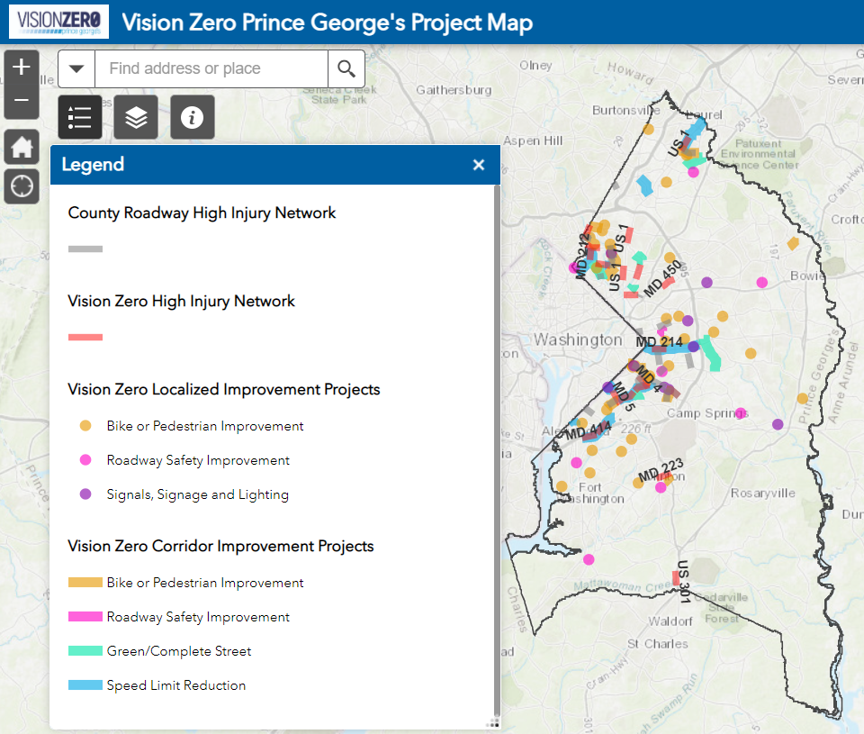
The map assists the planning efforts of DPW&T and partner agencies by documenting where safety improvements have been constructed or are being constructed. It also demonstrates Prince George’s County’s efforts towards Vision Zero, which is a goal to eliminate roadway fatalities and serious injuries by 2040. The Vision Zero Prince George’s Project map is a living document, and it will be updated as safety projects are implemented.

Features
- Navigating the map
You can view different parts of the map by clicking and dragging along any part of the map.
You can zoom in and out using the mouse wheel, or by using the + and – icons on the screen.
If you are lost, you can always return to the default view by clicking on the house icon.
You can also search a location by typing the address into the search bar next to the magnifying glass.

- View project information
You can view more detailed information about any feature on the map by clicking on it. Clicking on a project will show its description, status, project type, responsible agency, and other information. Clicking on a grey or red High Injury Network will display its roadway name, route, and severity index, which is calculated based on the frequency and severity of bike and pedestrian crashes along the corridor.

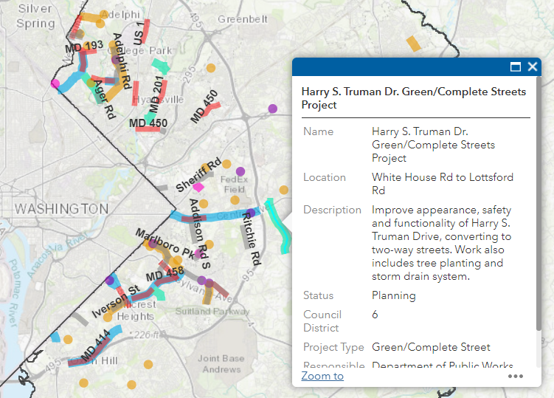

You can also view a list of all the projects on the map by opening the attribute table. The attribute table can be accessed by clicking the triangle icon at the bottom of the screen.
- Turn layers on and off
You can turn layers on and off by clicking the layer icon and clicking the associated check boxes for each layer.
To show the legend again, click the icon that looks like a list.
To learn more about the map and about Vision Zero Prince George’s click the information icon.

Learn more about Vision Zero Prince George’s by visiting www.visionzeroprincegeorges.com
Updated 4/9/2021

